**Assignment 03**

**248518**

**Gaurav Balasaheb Raskar**

Q.1.,Q.2.,Q.3.&Q.4.

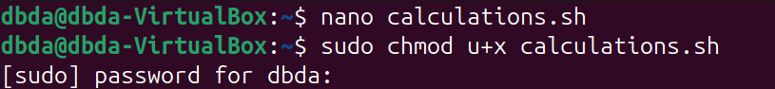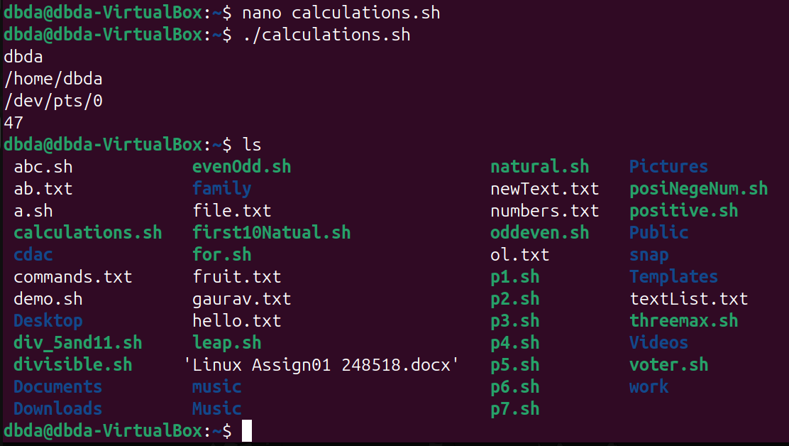

Q.I.,Q.II.&Q.III.

